
UNIT II: Arrays,
Searching, and Sorting
By – Dr. Dipalee D. Rane
(COMPUTER ENGG, DYPCOE, AKURDI, PUNE)

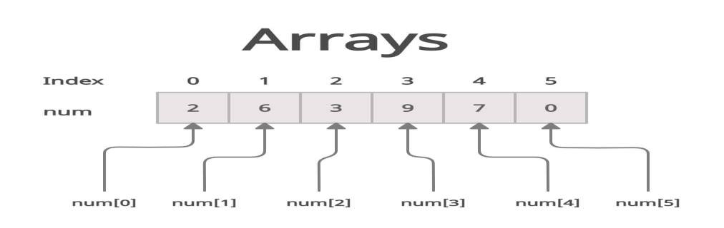

Overview of Array
What is an Array?
Anarrayisalineardatastructurethatstoreselementsofthesame data type in a contiguous block of memory, accessed using indices.
Key Characteristics
Fixed size (static allocation)
Elements are indexed from 0 to n-1
Random access enabled (O(1) time complexity)Efficient storage and access for homogeneous data

Overview of Array
Types of Arrays
One-Dimensional Array (1D): Simple list of elements
(e.g., int arr[5] = {1, 2, 3, 4, 5})
Two-Dimensional Array (2D): Matrix-like structure
(e.g., int matrix[3][3])
Multidimensional Array (nD): Higher-level data representations (e.g., tensor-like structures in ML)
Real-World Applications
Storing marks of students
Representing matrices and imagesLookup tables
Buffering and caching systems

Array as an Abstract Data Type
What is an Abstract Data Type (ADT)?
An ADT is a theoretical model that defines:The data to be stored
The operations allowed on that data
without specifying the internal implementation
Array as an ADT
An array as an ADT defines:
A collection of elements of the same typeFixed size (defined at creation)
Indexed access using position

Array as an Abstract Data Type
Advantages of Array as ADT
Random Access
Simplicity
Memory Locality
Efficient Iteration
Disadvantages of Array as ADT
Fixed Size
Costly Insertions/Deletions
Wasted Memory
Inefficient for Dynamic Operations

Operations on Arrays
1. Traversal
Visiting each element of the array from start to endUsed for displaying, summing, or processing all elements🕒Time Complexity: O(n)
2. Insertion
Adding an element at a specific indexRequires shifting elements to the right🕒Time Complexity:
• Best Case (end insertion): O(1)
• Worst Case (front insertion): O(n)

Operations on Arrays
➖3. Deletion
Removing an element from a specific index
Requires shifting elements to the left to fill the gap🕒Time Complexity: O(n)
📝4. Updating
Replacing an element at a given index with a new value🕒Time Complexity: O(1)
🔍5. Searching
Finding the position of an element
Types: Linear Search O(n), Binary Search O(log n) (if sorted)

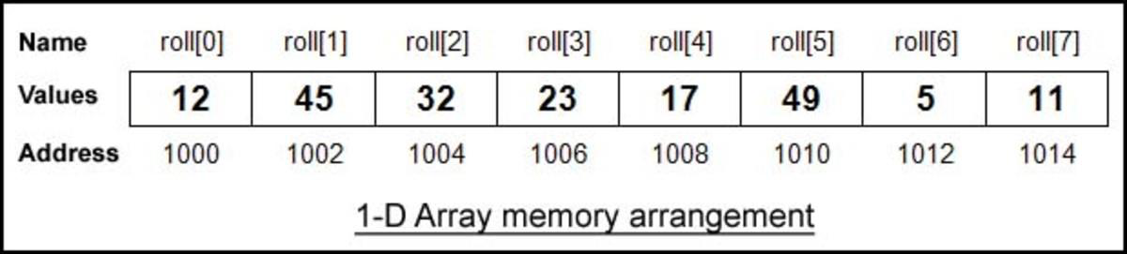
Storage Representation
How Arrays are Stored in Memory
Arrays are stored in contiguous blocks of memory
Each element is placed at a memory address calculated using: Address=Base Address+(i×Size of data type)
1D Array Storage
Elements are laid out sequentially
Enables constant-time access using index

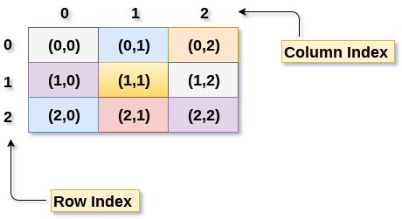
Multidimensional Arrays [2D, nD]
What is a Multidimensional Array?
A multidimensional array is an array of arrays. It allows storing data in table-like (2D) or cube-like (nD) structures.
2D Array
Represents a matrix with rows and columnsDeclaration example in JAVA:
int arr[][] = new int[2][3];
Accessed using: matrix[i][j]
Applications:
Image processing, Graph representations, Matrix operations

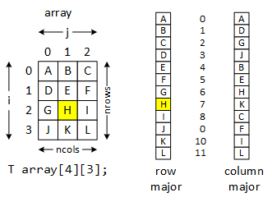
Multidimensional Arrays [2D, nD]
2D Array Storage
There are two common representations:
1.Row-Major Order
All elements of the first row are stored first, followed by second, and so on.
2.Column-Major Order
All elements of the first column are stored first, followed by second, and so on.

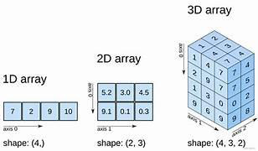
Multidimensional Arrays [2D, nD]
nD Array
Extension of 2D array into multiple dimensions
Useful in advanced simulations, tensor computations, etc.
Example: int tensor[3][4][2];
Applications:
Machine learning (tensors), physics simulations, 3D graphics

Sparse Matrix
Representation using 2D Arrays
What is a Sparse Matrix?
A sparse matrix is a matrix in which most elements are zero. Storing all elements wastes memory and computation.
Why Use Sparse Representation?
Efficient storage of large matrices with few non-zero valuesReduces space complexity significantly
Speeds up matrix operations by ignoring zeros
Common Use Cases
Graph algorithms (adjacency matrix)Machine learning (feature vectors)Image compression

Sparse Matrix
Representation using 2D Arrays
Sparse Matrix using 2D Array
One popular method is the Triplet Representation (Row, Column, Value):
Row | Col | Value
-----|-----|-------
0 | 2 | 5
1 | 0 | 8
3 | 1 | 6
Here, only non-zero elements are stored along with their positions.

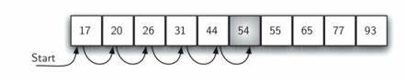
Searching Techniques
1. Sequential Search (Linear Search)
Check each element one by one
Works on unsorted arrays
 Time Complexity: O(n)
 Best Case: First element
 Worst Case: Last element or not found

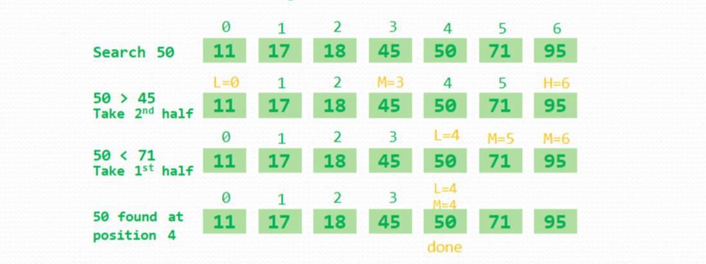
Searching Techniques
2. Binary Search
Works only on sorted arrays
Repeatedly divides the search space in half
 Time Complexity: O(log n)
 Requires sorting beforehand

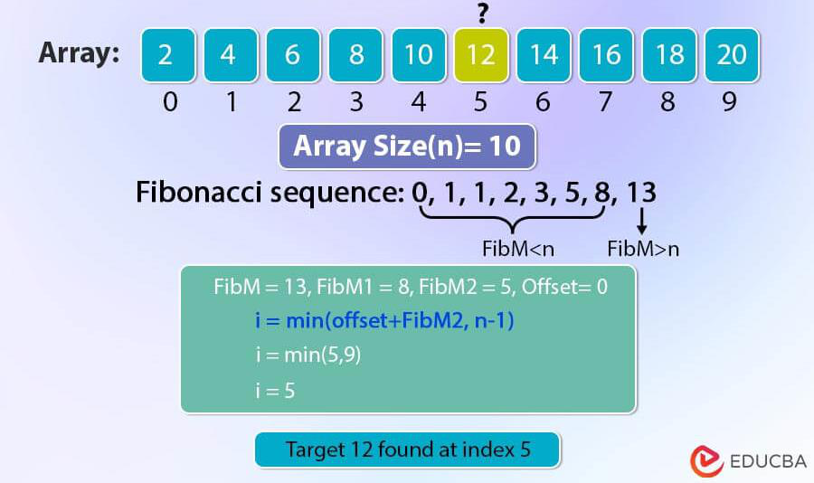
Searching Techniques
3. Fibonacci Search
Based on Fibonacci numbers for split positionsSuitable for large sorted arrays
 Time Complexity: O(log n)
Uses less division than binary search (faster on some machines)

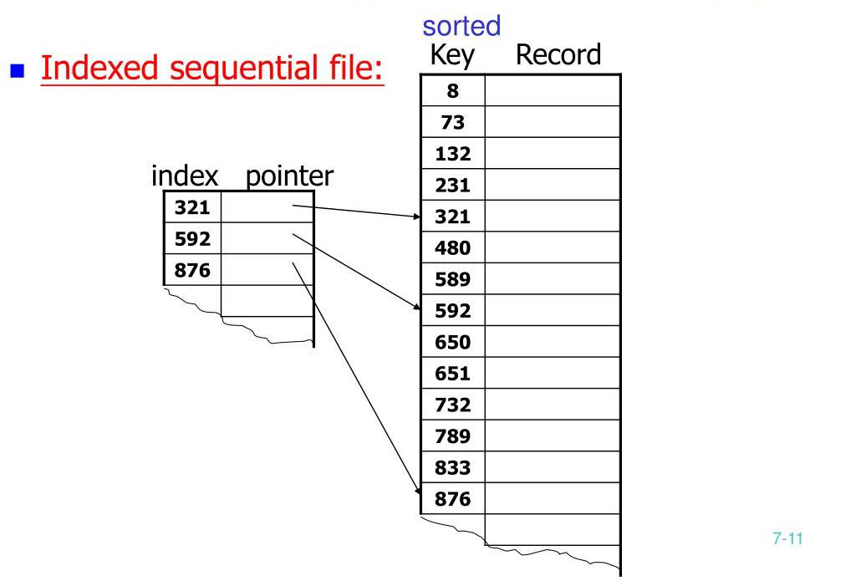
Searching Techniques
4. Indexed Sequential Search
Combine indexing with linear search
Use a separate index table for faster accessEfficient when working with large sorted datasets

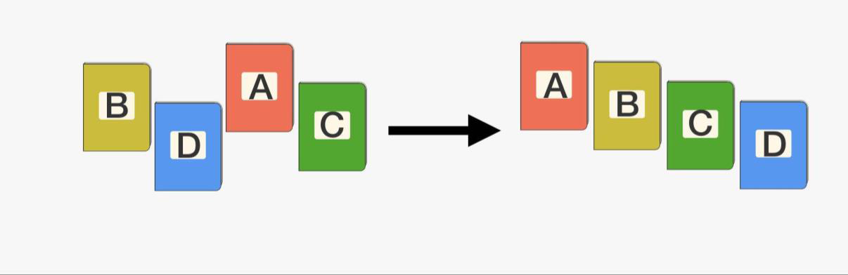
Sorting Concepts Why Sorting?
Sorting organizes data in a specific order (ascending/descending),
making searching and processing faster and more efficient.

Sorting Concepts
Key Concepts in Sorting
 1. Stability
A sorting algorithm is stable if it preserves the relative order of equal elements.
Example: In student list, two students with the same marks maintain their input order
2. Efficiency
Based on time and space complexity
Depends on best, average, and worst-case analysis

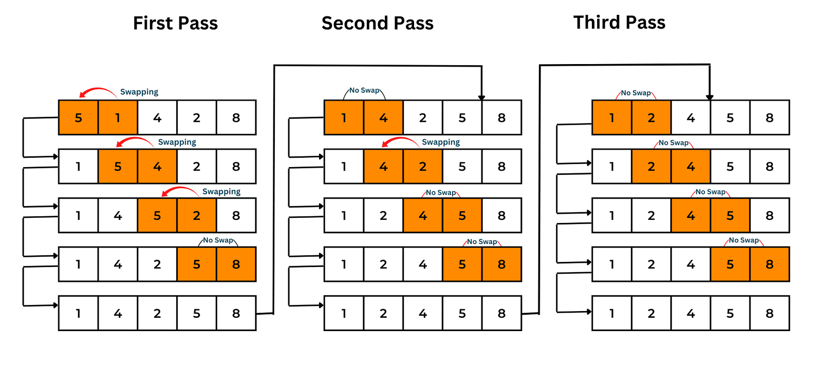
Sorting Algorithms
1. Bubble Sort
Compares adjacent elements and swaps if needed
Repeats until the list is sorted
Time: O(n²)
Stable
Easy but inefficient for large datasets

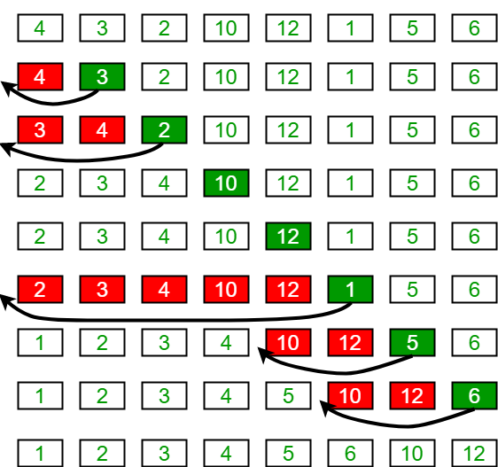
Sorting Algorithms
2. Insertion Sort
Builds sorted list by inserting one element at a time Time: O(n²)
Stable
Efficient for small or nearly sorted arrays

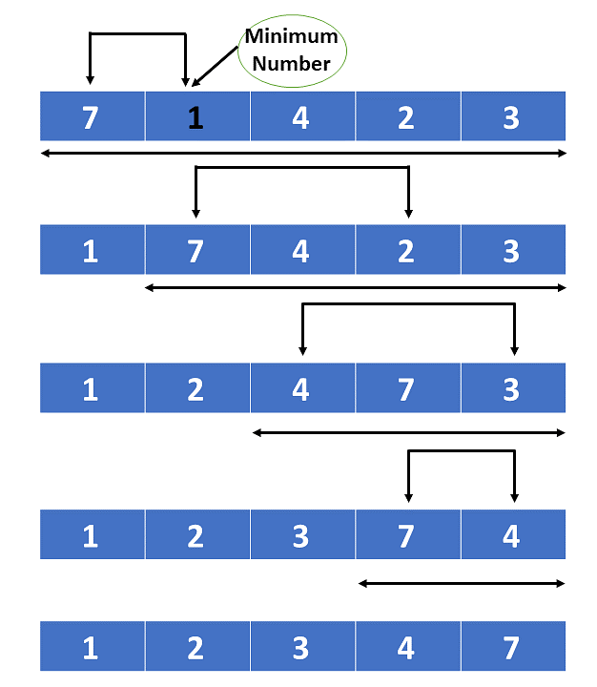
Sorting Algorithms
3. Selection Sort
Repeatedly selects the minimum element and places it at the front Time: O(n²)
Not Stable
Simple, but not efficient

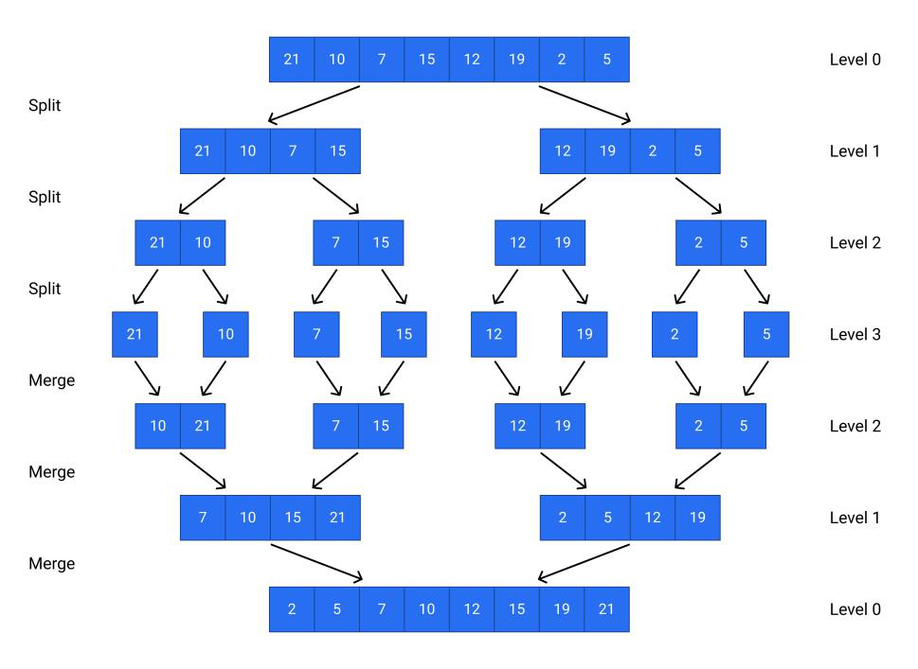
Efficient Sorting Algorithms
1. Quick Sort
Divide-and-conquer using pivot-based partitioning Time: O(n log n) average, O(n²) worst
Not Stable
Very efficient and widely used

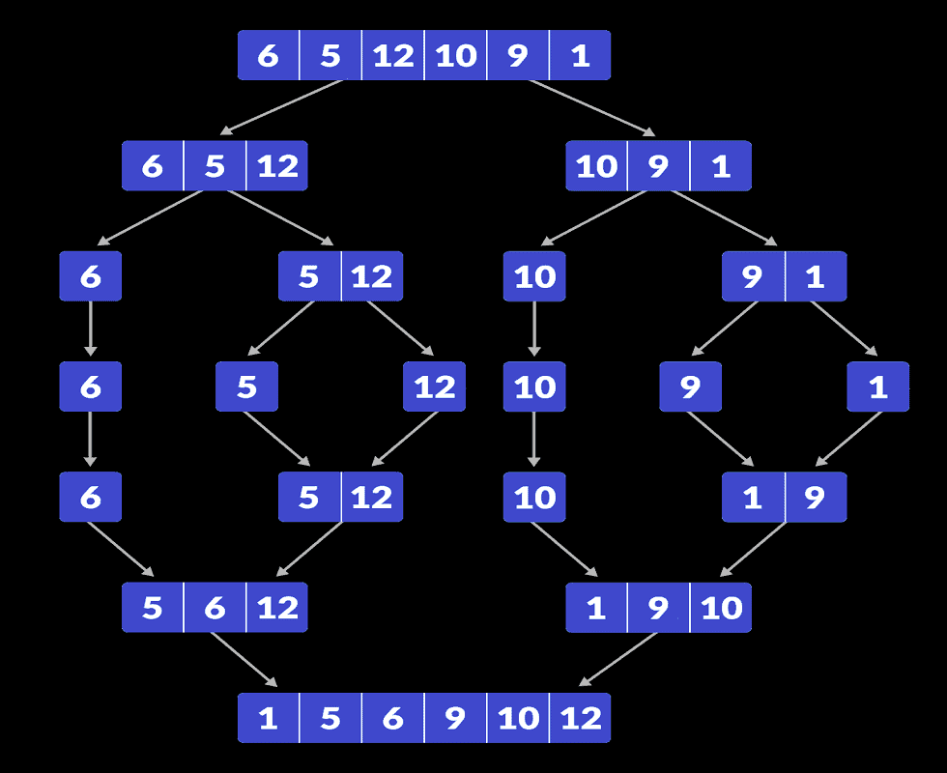
Efficient Sorting Algorithms
2. Merge Sort
Divide the array, sort halves, and merge Time: O(n log n)
Stable
Uses extra space, but reliable and consistent

Exemplar / Case Study: Social Network Adjacency Matrix
Use Case: Representing friendship connections in social media platforms.
Data Structure Used: 2D Adjacency Matrix.
Matrix Element: a[i][j] = 1 if user i is friends with user j, else 0.For millions of users, the matrix is very sparse.
Sparse matrix techniques help save memory and improve performance.
Useful in applications like friend suggestion, community detection, etc.

Text Books
1.Fundamentals of Data Structures in C – by Ellis Horowitz, Sartaj
Sahni, Susan Anderson-Freed Universities Press
2.Data Structures Through C - by Yashavant Kanetkar BPB
Publications

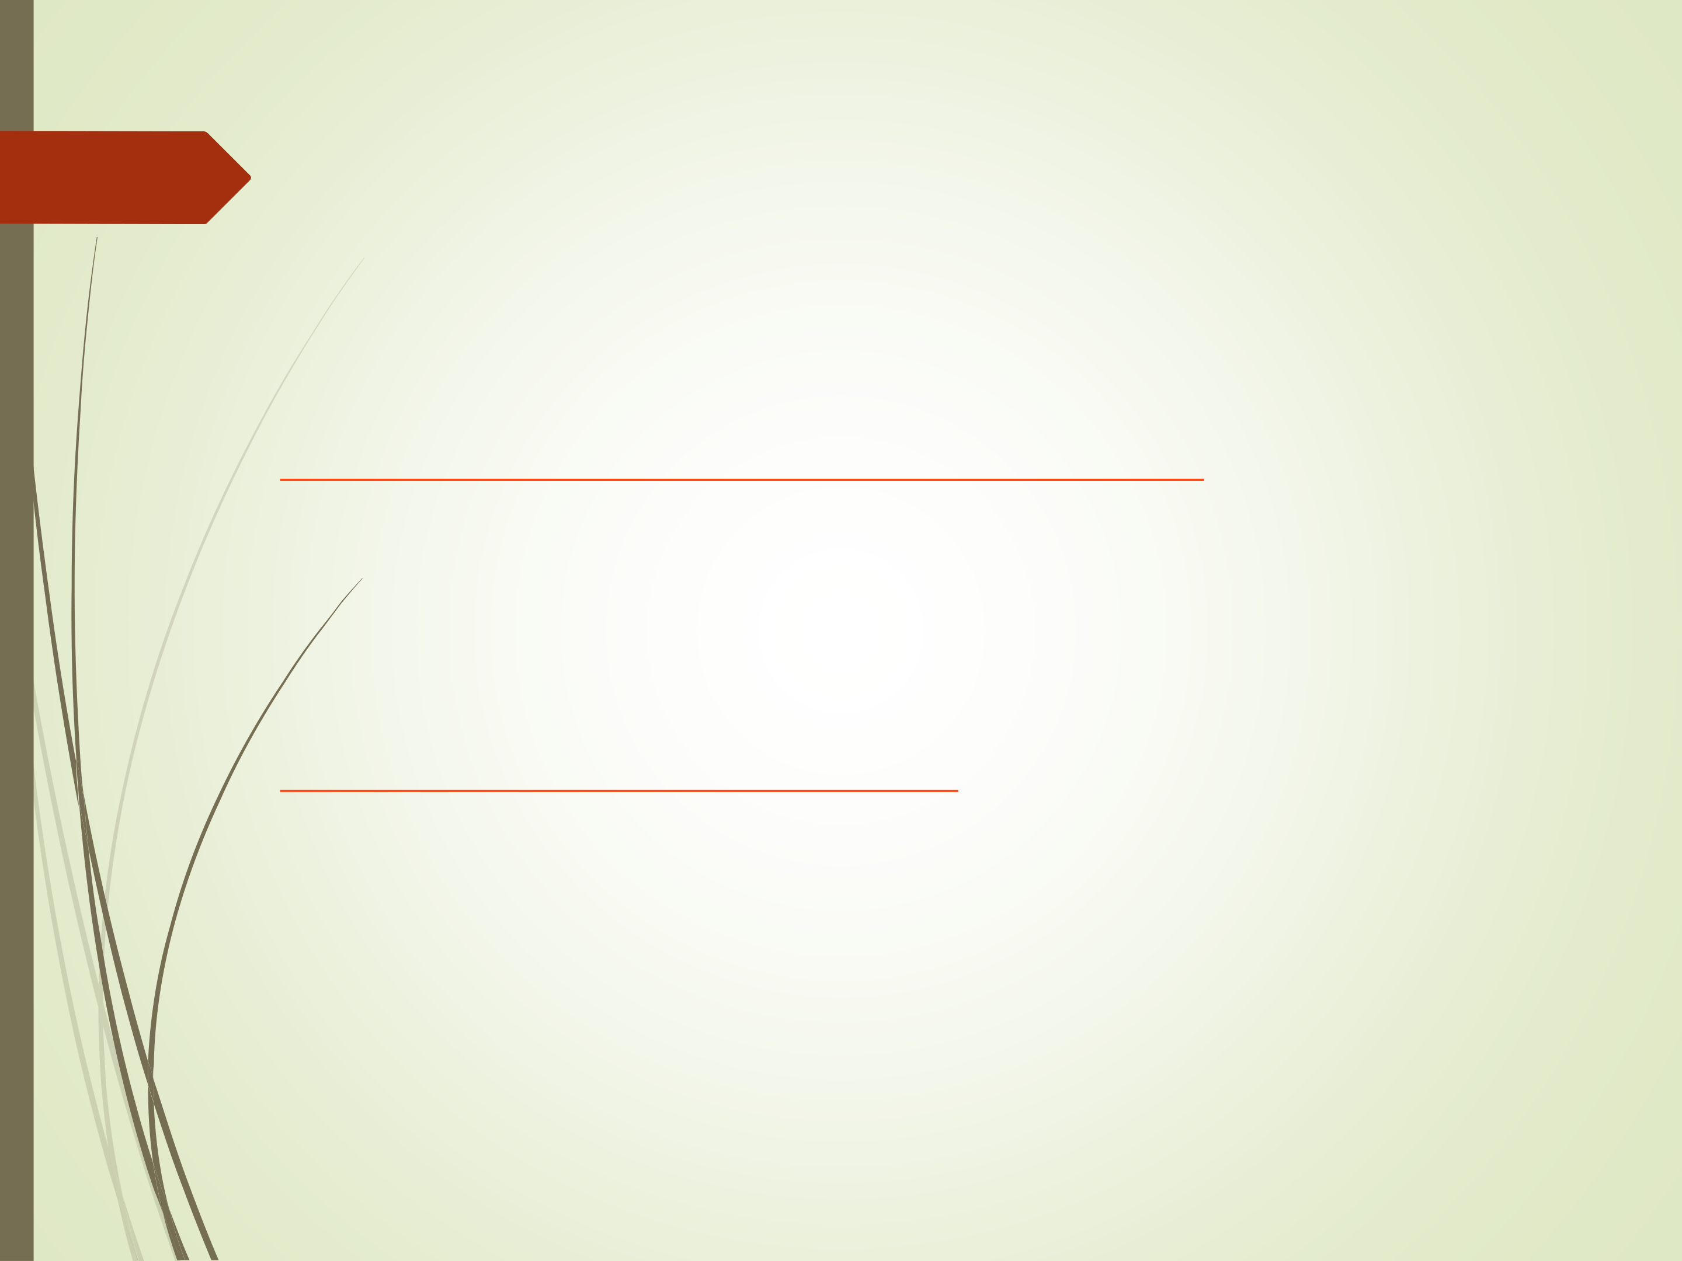
NPTEL Links
1.Sorting and Searching by IIT Kharagpur

2.NPTEL Course - NOC: Programming, Data Structures and
Algorithms using Python

